**CSA1513-Cloud computing and big data analysis**

**D.SARATH BABU-192311031**

**EXP NO 1:**

**CREATE A SIMPLE CLOUD SOFTWARE APPLICATION AND PROVIDE IT AS A SERVICE USING ANY CLOUD SERVICE PROVIDER TODEMONSTRATE SOFTWARE AS A SERVICE (SAAS).**

**DATE:**

**AIM:**

To create a simple cloud software application and provide it as a service using any cloud service provider todemonstrate software as a service (saas).

**PROCEDURE:**

**STEP1:** GOTO ZOHO.COM

**STEP 2:** LOGIN TO THE ZOHO.COM

**STEP 3:** SELECT ONE APPLICATION

**STEP 4:** ENTER APPLICATION NAME

**STEP 5:** CREATED NEW APPLICATION

**STEP 6:** SELECT ONE FORM

**STEP 7:** THE SOFTWARE HASE BEEN CREATED.

**IMPLEMENTATION:**

# STEP1: GOTO ZOHO.COM

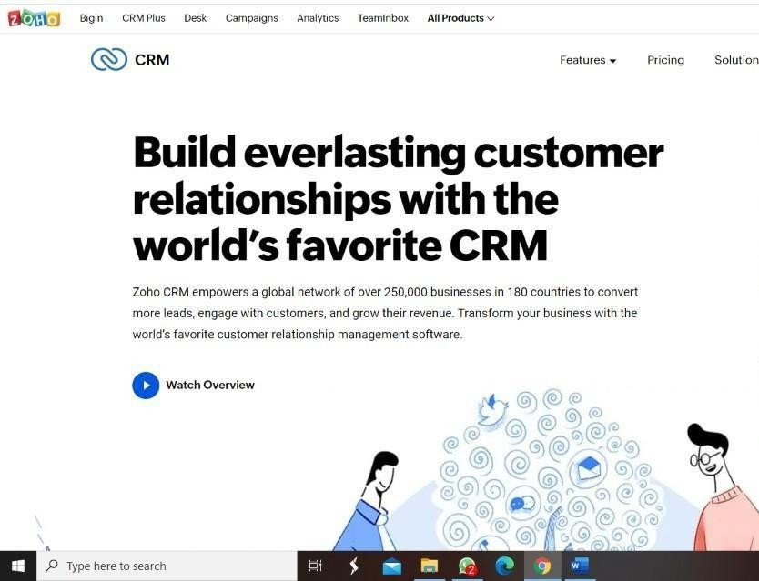

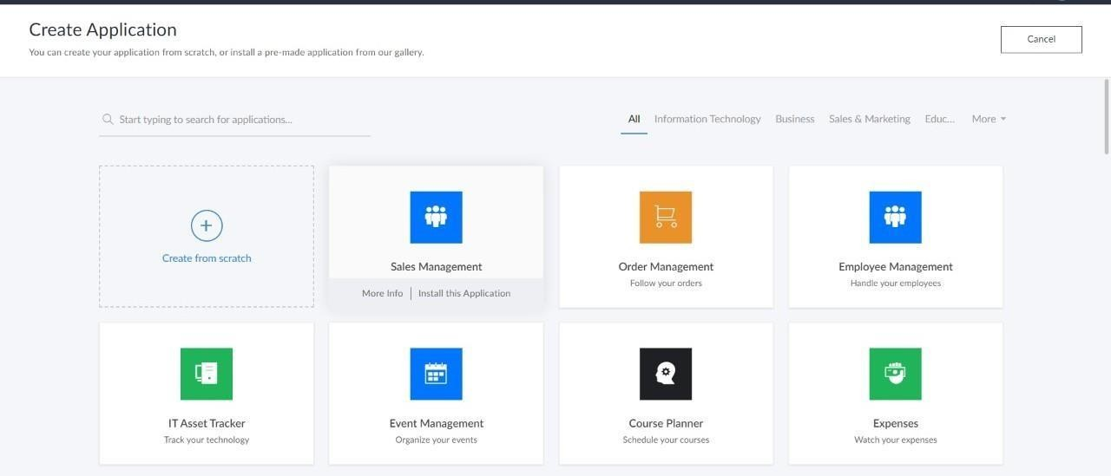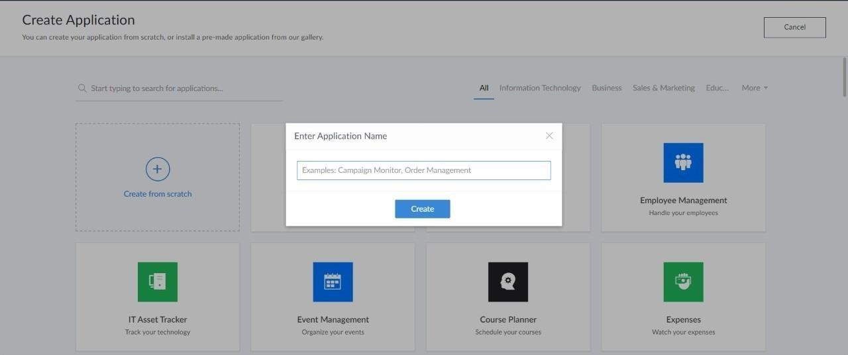**STEP 2: LOGINTOTHE ZOHO.COM**

**STEP 3: SELECT ONE APPLICATION**

**STEP 4: ENTER APPLICATION NAME**

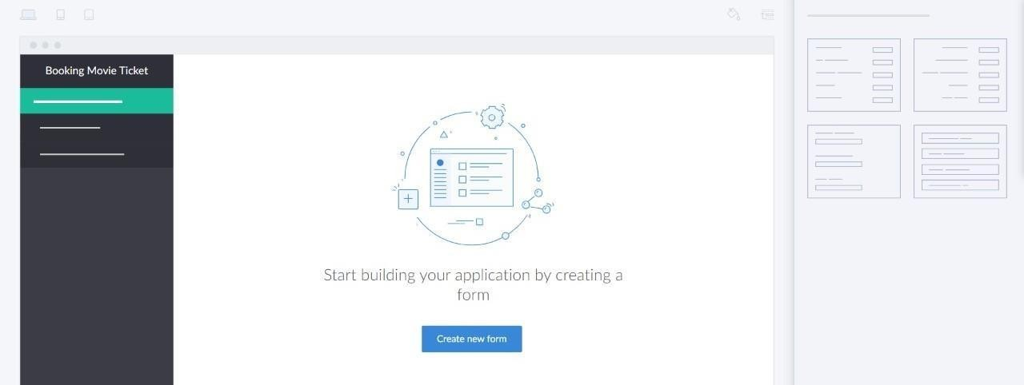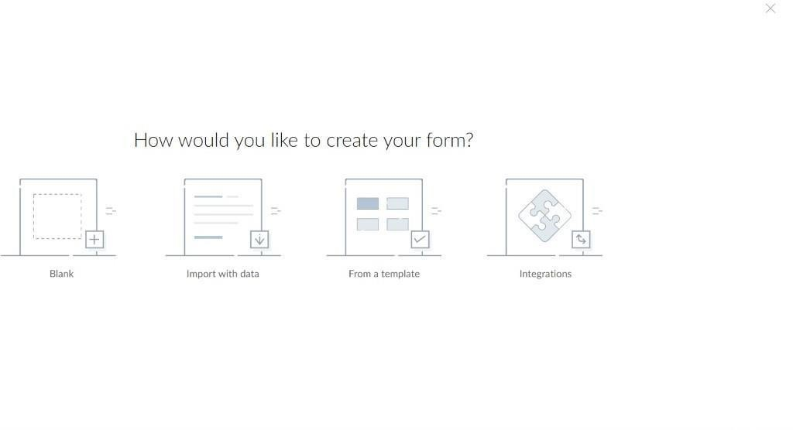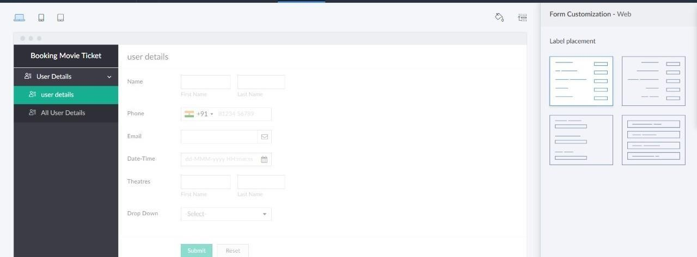**STEP 5: CREATED NEW APPLICATION**

# STEP 6: SELECT ONE FORM

**STEP 7: THE SOFTWARE HASE BEEN CREATED.**

